Batch: A-3 Roll No.: 16010122104

Experiment No.: 4

Grade: AA / AB / BB / BC / CC / CD /DD

Signature of the Staff In-charge with date

TITLE: Project Plan document for Mini Project

AIM: To learn and understand the way of developing the software by classical methods of software engg. planning and monitoring of the project using tools and prepare a document for the same by using the concept of software engineering ______________________________________________________________________
Expected OUTCOME of Experiment:
Analyse the software requirements and Model the defined problem with the help of UML diagram
_____________________________________________________________________
Books/ Journals/ Websites referred:

1. Roger Pressman, Software Engineering: A practitioners Approach, McGraq Hill, 2010 ,6th edition
2. Ian Somerville , Software Engineering , Addison Wesley,2011,9th edition
- http://en.wikipedia.org/wiki/Software_requirements_specification

_____________________________________________________________________

Software Project Management Plan
for
ManSeek: Mental Health App
Kashish Mehul Mamania
10/10/2024
Version | Release Date | Responsible Party | Major Changes
0.1 |  | Project Manager, Development Team | Initial Document Release for Comment
Table of Contents
- Introduction 1.1. Project Overview
1.2. Project Deliverables
1.3. Evolution of the SPMP
1.4. Reference Materials
1.5. Definitions and Acronyms
- Project Organization 2.1. Process Model
2.2. Organizational Structure
2.3. Organizational Interfaces
2.4. Project Responsibilities
- Managerial Process 3.1. Management Objectives and Priorities
3.2. Assumptions, Dependencies, and Constraints
3.3. Risk Management
3.4. Monitoring and Controlling Mechanisms
3.5. Staffing Approach
- Technical Process 4.1. Methods, Tools, and Techniques
4.2. Software Documentation
4.3. User Documentation
4.4. Project Support Functions
- Work Packages, Schedule, and Budget 5.1. Work Packages
5.2. Dependencies
5.3. Resource Requirements
5.4. Budget and Resource Allocation
5.5. Schedule
- Additional Components

1. Introduction
1.1 Project Overview
The ManSeek Mental Health Application aims to create an accessible, secure platform for users to track mental health, access guided mindfulness exercises, connect with mental health professionals, and provide crisis support. The application includes features like Mood Tracking, Mindfulness and Relaxation Techniques, Sleep Tracking, Crisis Support, and a Therapist Directory. The project will be developed using Flutter for frontend and Firebase for backend services. The project is scheduled for deployment on 15th January 2025.
1.2 Project Deliverables
- User Authentication and Profile Management Module (Delivered by 20th December 2024)
- Mood Tracking and Journal Module (Delivered by 24th December 2024)
- Mindfulness & Sleep Tracking Module (Delivered by 30th December 2024)
- Crisis Support and Therapist Directory (Delivered by 30th December 2024)
1.3 Evolution of the SPMP
This document will be updated based on development milestones and feedback. Major updates will be tracked, and any unscheduled updates will be handled through change management procedures.
1.4 Reference Materials
- Software Requirements Specification (SRS) for ManSeek
- Pressman, Roger. Software Engineering: A Practitioner's Approach, McGraw-Hill, 2010.
- Somerville, Ian. Software Engineering, Addison Wesley, 2011.
1.5 Definitions and Acronyms
- SPMP: Software Project Management Plan
- SRS: Software Requirements Specification
- UAT: User Acceptance Testing

2. Project Organization
2.1 Process Model
We will use an Agile Development process for this project, with 2-week sprints for continuous delivery of features and regular feedback from stakeholders. This model supports flexibility and frequent updates, which is necessary for the iterative development of the ManSeek application.
2.2 Organizational Structure
- Project Manager: Oversees project progress and coordinates between teams.
- Development Team: Responsible for frontend, backend development, and testing.
- QA Team: Handles quality assurance and user acceptance testing.
- Design Team: Develops UI/UX and user flow diagrams.
- Stakeholders: Includes end users, mental health professionals, and regulatory bodies.
2.3 Organizational Interfaces
Organization | Liaison
Customer | Kashish
Subcontractor | Kashish
SQA Team | Kashish
2.4 Project Responsibilities
Role | Description | Person
Project Manager | Leads project, coordinates teams, and ensures deliverables | Kashish
Technical Team Leader | Supervises development team, ensures code quality | Kashish
QA Lead | Handles all quality assurance and testing | Kashish

3. Managerial Process
3. Managerial Process
3.1 Management Objectives and Priorities
The priority is to deliver a high-quality, secure mental health platform that adheres to deadlines while maintaining flexibility in scope to incorporate feedback. The flexibility matrix is as follows:
Project Dimension | Fixed | Constrained | Flexible
Cost |  | X
Schedule | X
Scope |  |  | X
3.2 Assumptions, Dependencies, and Constraints
- Assumes Flutter and Firebase integration will remain stable.
- Dependent on stable internet access for users to interact with the platform.
- The project is constrained by privacy and regulatory standards such as GDPR and HIPAA.
3.3 Risk Management
- Technological Risks: Integration issues with external services (Firebase). Mitigation: Early testing and API monitoring.
- Regulatory Risks: Non-compliance with GDPR or HIPAA. Mitigation: Regular legal audits.
3.4 Monitoring and Controlling Mechanisms
Information Communicated | From | To | Time Period
Status Report | Development Team | Project Manager | Weekly
Status Report | Project Manager | Stakeholders | Bi-Weekly
Project Review | QA Team | Project Manager | Monthly
3.5 Staffing Approach
The team requires developers skilled in Flutter, Firebase, and UI/UX design. Training sessions on security protocols and privacy standards (e.g., GDPR) will be provided.
4. Technical Process
4.1 Methods, Tools, and Techniques
- Development Tool: Flutter for cross-platform mobile development, Firebase for backend services.
- Languages: Dart (Flutter), SQL (Database).
- Testing Tools: Jest, Flutter Testing Framework.
4.2 Software Documentation
- SRS Document: To clearly define all the functional and non-functional requirements.
- Software Design Description (SDD): To detail the architecture and module breakdowns.
4.3 User Documentation
- User Manual: Available in PDF, covering authentication, mood tracking, and more.
- In-App Help: Context-sensitive help accessible in the app.

5. Work Packages, Schedule, and Budget
5.1 Work Packages
- WP1: UI Design
- WP2: Frontend Development (Authentication, Mood Tracking)
- WP3: Backend Development (Firebase Integration)
- WP4: Testing (Unit and System Testing)
5.2 Dependencies
WP2 is dependent on WP1 completion, while WP3 can begin concurrently with WP2.
5.3 Resource Requirements
The project will require 5 Flutter Developers, 2 UI Designers, and 3 QA engineers over a 3-month period.
5.4 Budget and Resource Allocation
Task | Budget Allocation
UI/UX Design | Rs. 10,000
Development (Frontend + Backend) | Rs. 30,000
Testing | Rs. 8,000
5.5 Schedule
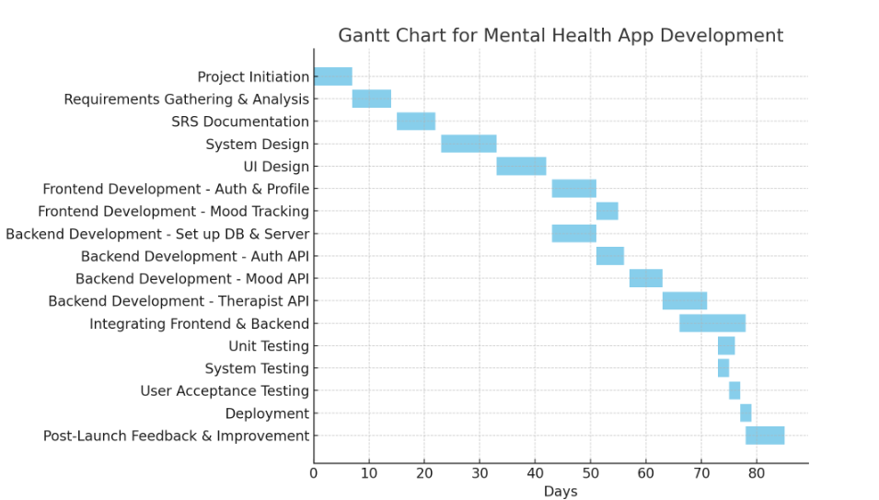

Conclusion:
This filled-in project plan can now be used as a reference for the ManSeek Mental Health App.

Post Lab Descriptive Questions
- State various Scheduling principles and explain them in detail.

